Going to <https://github.com> 🡪

**Create a new repository** -🡪 A repository contains all the files for your project, including the revision history

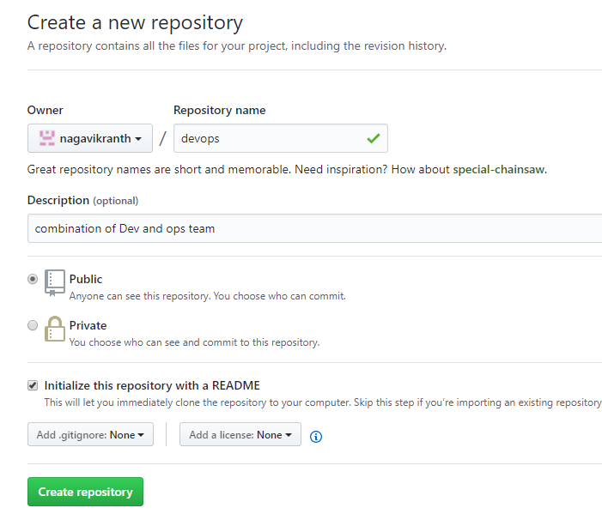

Click on Create repository.

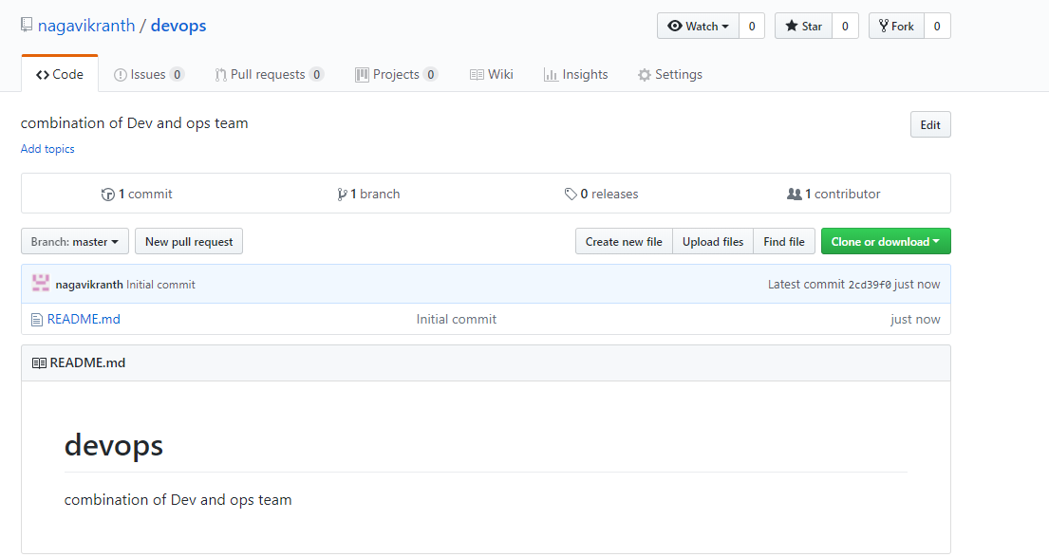

Download and install git bash into your local system.

<https://git-scm.com/downloads>

Open the Git Bash and create on directory. And change to that directory

**mkdir project**

**cd project**

**ls**

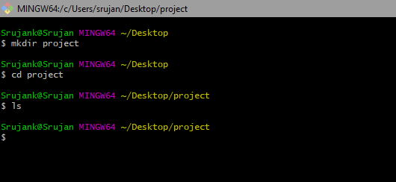

* **Configure the author name and email address to be used with your commits, identify purpose**

**git config --global user.name "nagavikranth"**

**git config --global user.email "vikranthaws@gmail.com"**

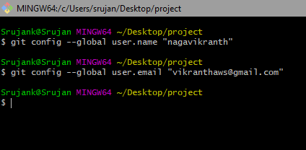

* **Clone the repo to your local system -🡪 go to git hub repo 🡪click on clone or download copy the https url**

**git clone “**[**https://github.com/nagavikranth/devops.git**](https://github.com/nagavikranth/devops.git)**”**

**ls**

**devops**

**cd devops**

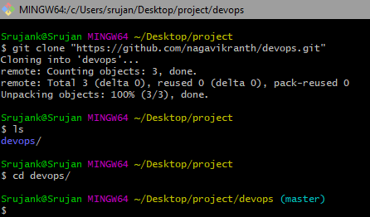

* **Create the file and add to the git ---- cat > index -🡪 git add –A**

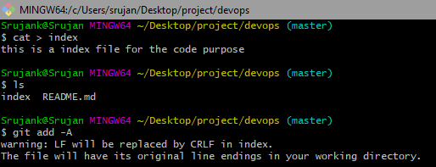

* **How to view git status-🡪 current state of the repository**

**git status**

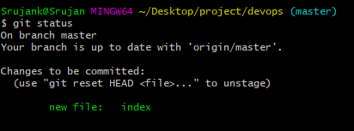

* **How to commit the file---🡪 changes made to the files to a local repository**

**git commit –m “write message”**

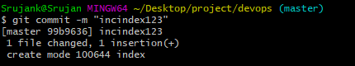

* **Check status of git---- current state of the repository**

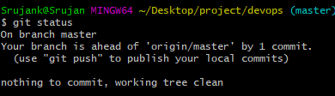

* **How to push the from the local to git hub central repo**

**git push origin master**

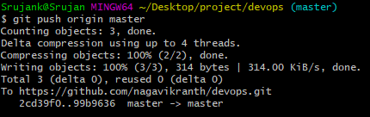

* **Check the index file is updated in git hub or not**

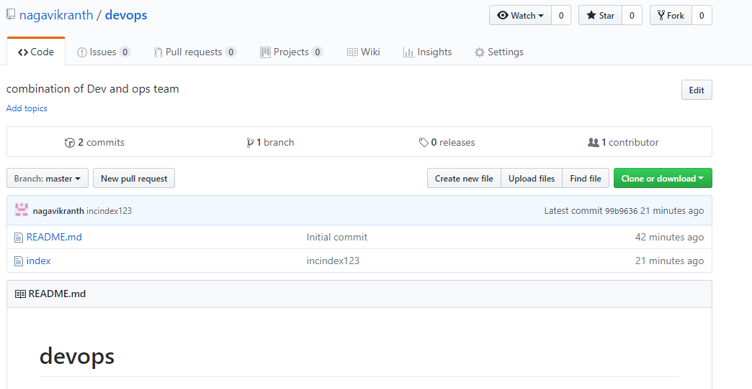

* **How to Viewing the Commit History..-🡪 to Viewing the Commit History**

**Git log**

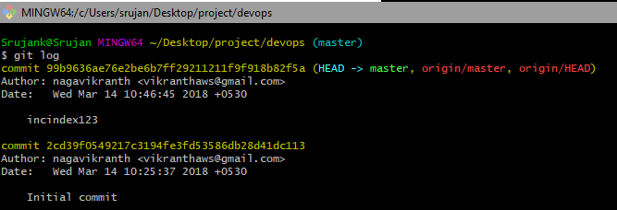

* **To Viewing the Commit History with file Name -🡪**

**git log --summary**

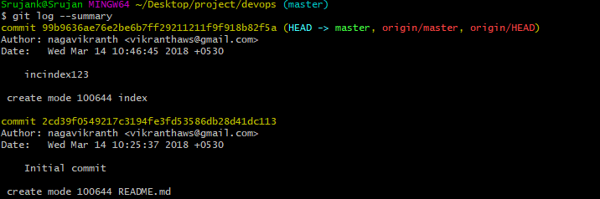

* **Adding and committing and pushing the file to github repo**

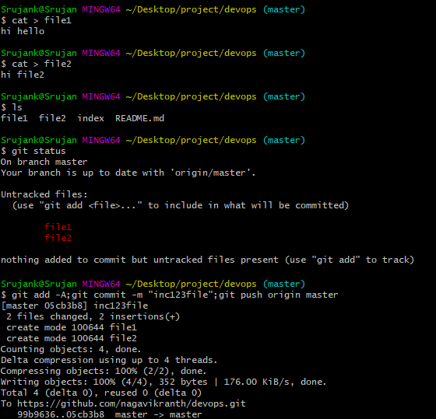

* **Check file are updated into github central repo.**

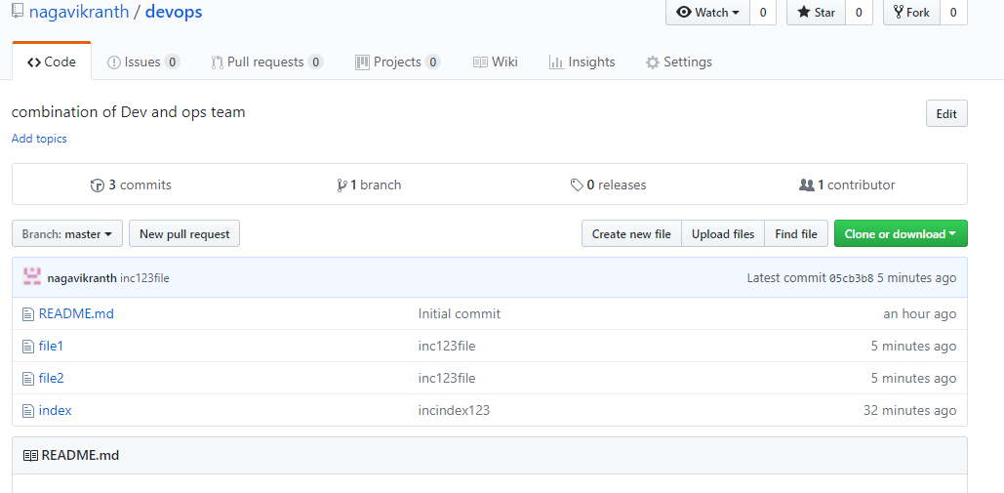

* **Getting updated file from github central repo to local system**

**git pull origin master**

**Before that create one file in github devops repo.**

**Click on new file -🡪 write file name aws🡪 in edit view write the matter**

**Write the commit message and commit the new file.**

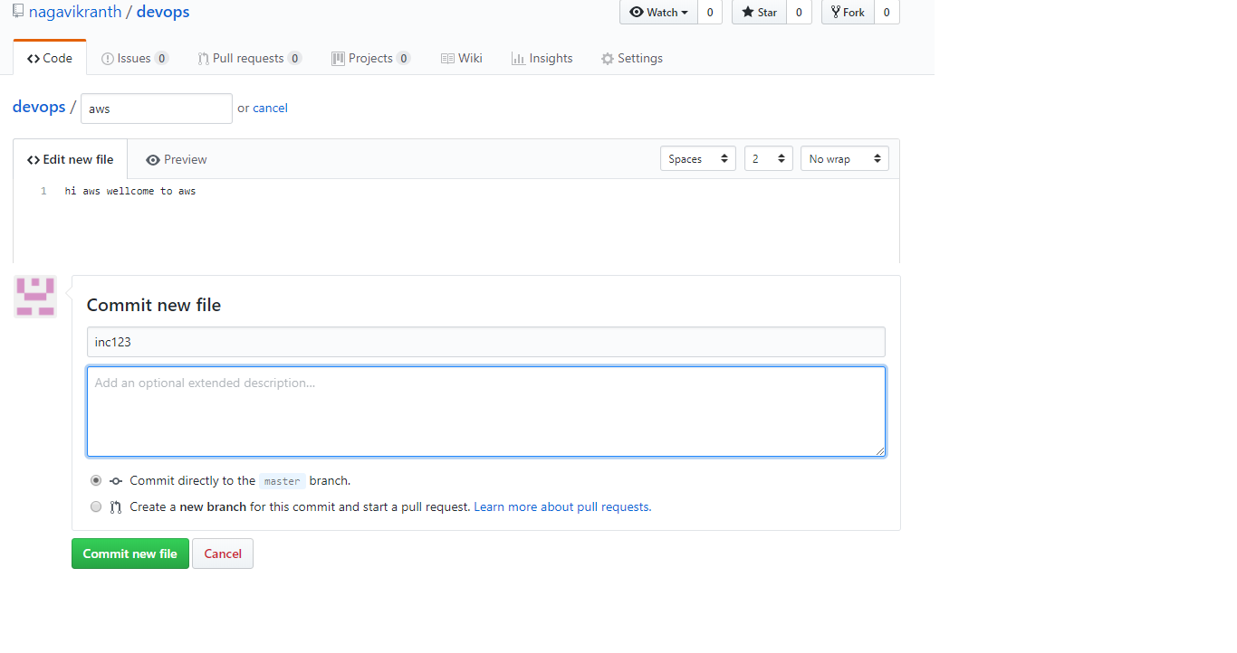

**Now check**

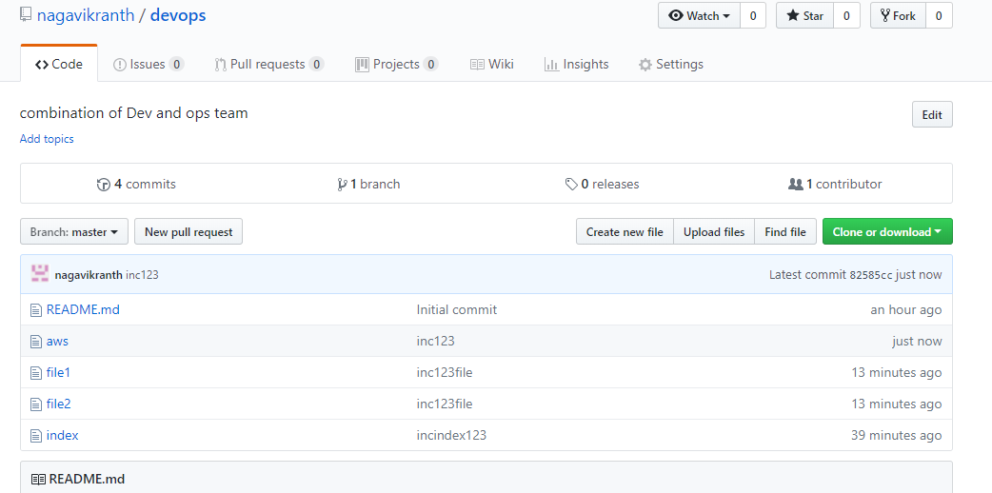

**Now check on ur local system.**

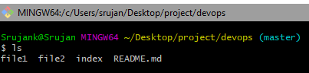

**Aws file was not there in local system….-🡪 if u want to get updated files from github central repo to local system**

**U need write the command**

**git pull origin master**

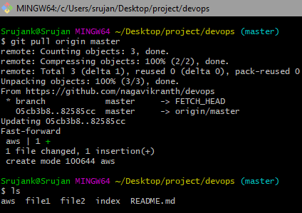

**Checks now the file are sync to local system**

* **How to modify the file in git**

**ls**

**vi <file name> 🡪 vi index**

**esc i -🡪 insert mode, write the matter-🡪 after that esc :wq!-🡪 file will be save**

**now see the file modified**

**cat <file name> 🡪 cat index**

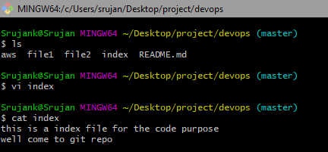

**Now add and commit and push the file**

**git add -A;git commit -m "inc345";git push origin master**

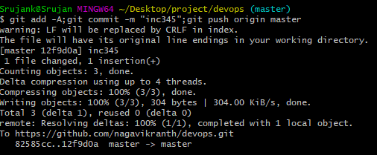

**Check on github devops repo.**

99b9636ae76e2be6b7ff29211211f9f918b82f5a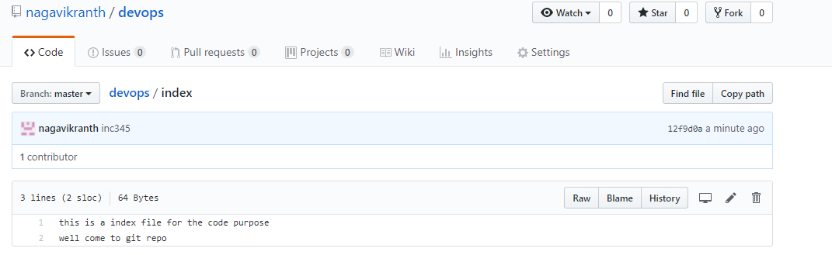

* **Now how can you get the last committed file of index for that or Revert back the last commit of the files.**

**View the git log and copy the hash code give the command**

**git checkout <committed hash code> file name**

**git log --summary**

**git checkout 99b9636ae76e2be6b7ff29211211f9f918b82f5a index**

**ls**

**cat index**

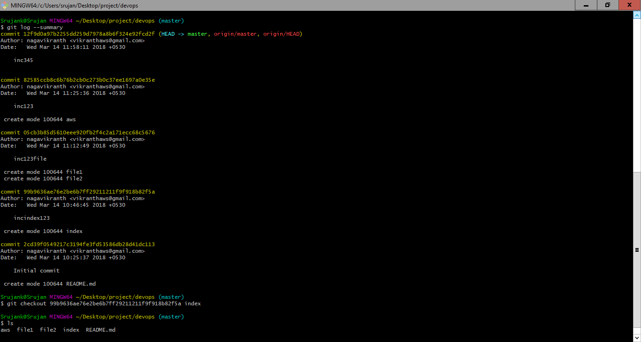



**After that add and commit and push the file to github**

**Revert back the last commit of the files..**

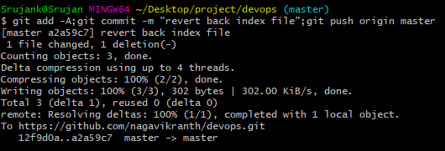

**Now check into the github devops repo -🡪 index file**

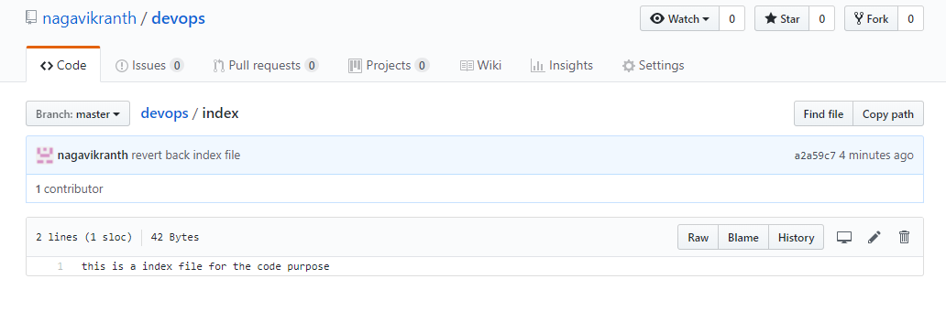

* **How to remove the file from git**

**git rm <file name>**

**git rm index**

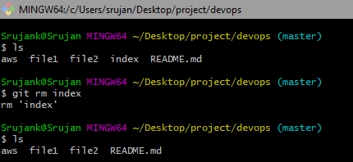

**That file was deleted in ur local system not in github**

**Check in github file not removed**

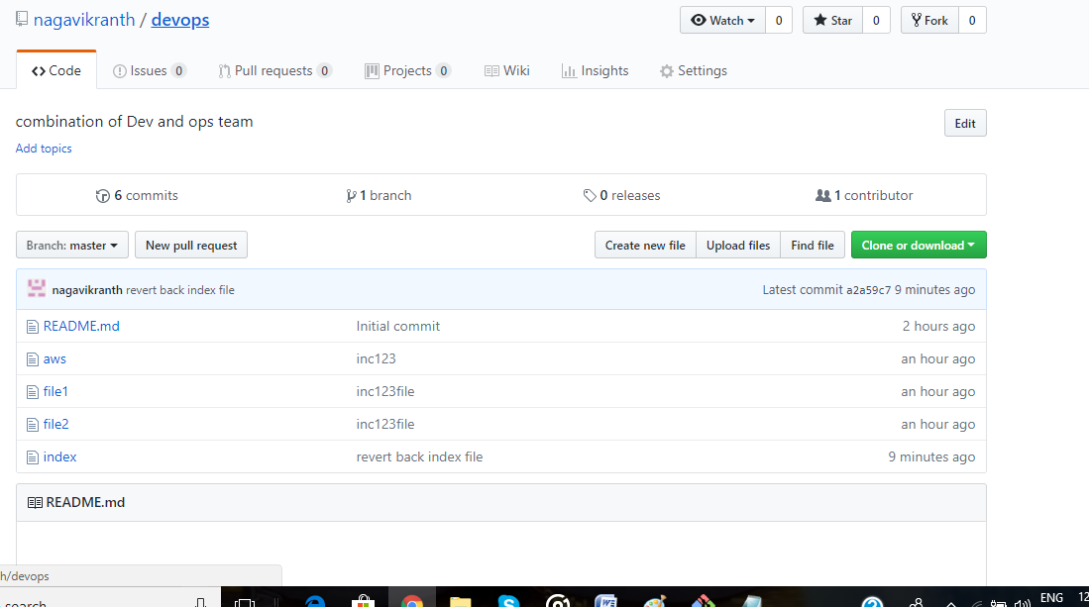

**if u want to remove to the github central repo**

**U has to add and commit and push the file.**

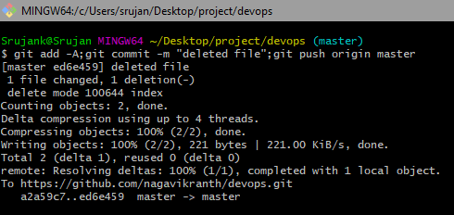

**Now check on github repo**

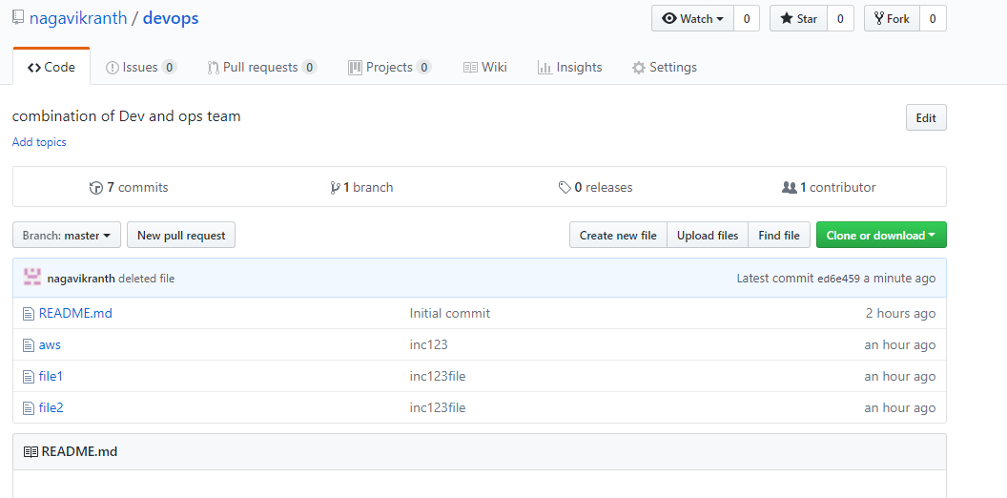

**File removed from the github**

* **How do u get the deleted file from the git-🡪 git log –summary-🡪 copy the committed file hash code**

**git checkout <committed file hash ID>^1 <file name>**

**git checkout ed6e459c76f8c062b810ba2bfb28f6b18e3fe980^1 index**

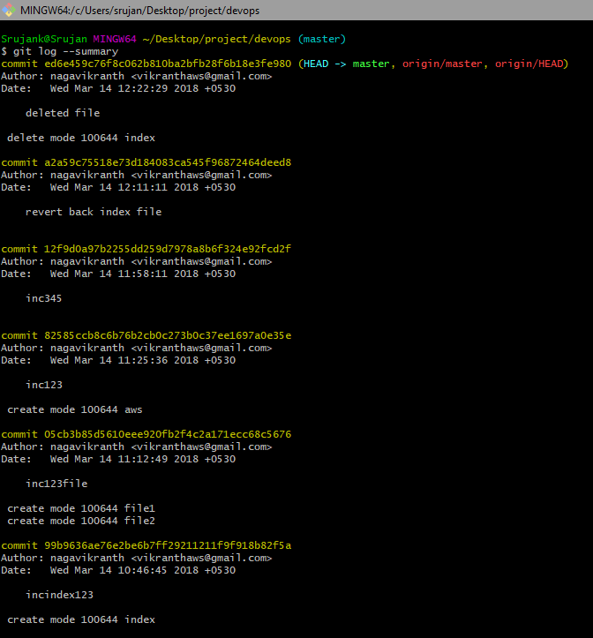

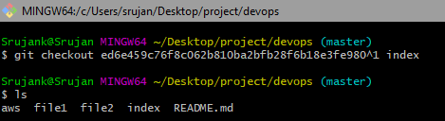

**So the deleted file was recover in local system**

**If u want to get into the github repo.**

**Add and commit and push the file**

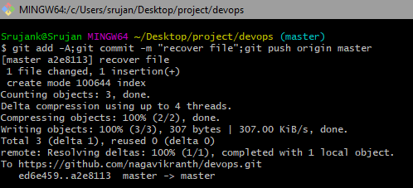

**Check on git hub repo**

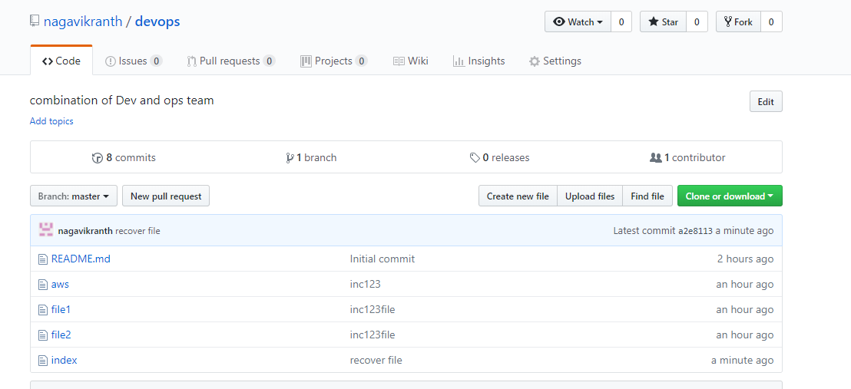

* **How to get List named remote repositories**

**git remote -v**

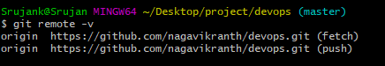

* **How add or to connect a remote Repo**

**git remote add <remote Name> <remote repo url>**

**git remote add bitbucket “**[**https://vikranthDevops@bitbucket.org/vikranthDevops/banking.git**](https://vikranthDevops@bitbucket.org/vikranthDevops/banking.git)**”**

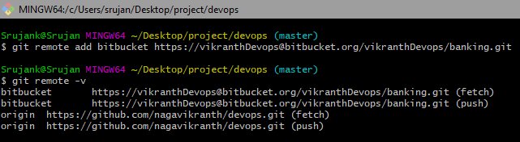

**I am added remote my bitbucket**

**I am in git devops repo… but I want to add file into the bitbucket**

**Now I am adding and committing and push the file remotely to bitbucket**

**I am not cloning the repo..**

**See how it**

**This is my bitbucket repo i.e banking and having these files**

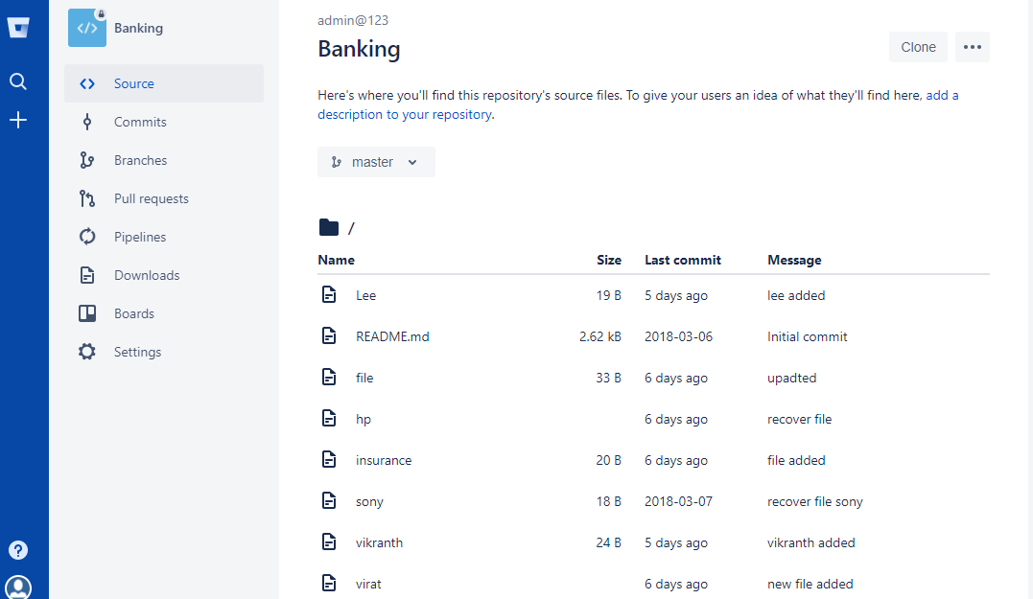

**Now I am adding and committing and pushing file to bit bucket**

**Creating file book**

**cat > book**

**ls**

**git add –A;git commit –m “book123”;git push bitbucket master**

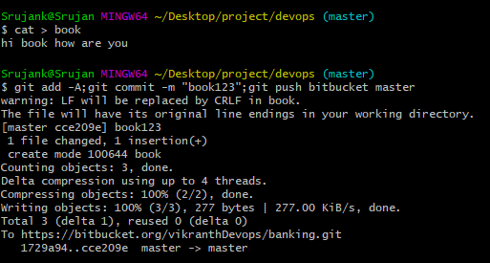

**Now check into bitbucket repo**

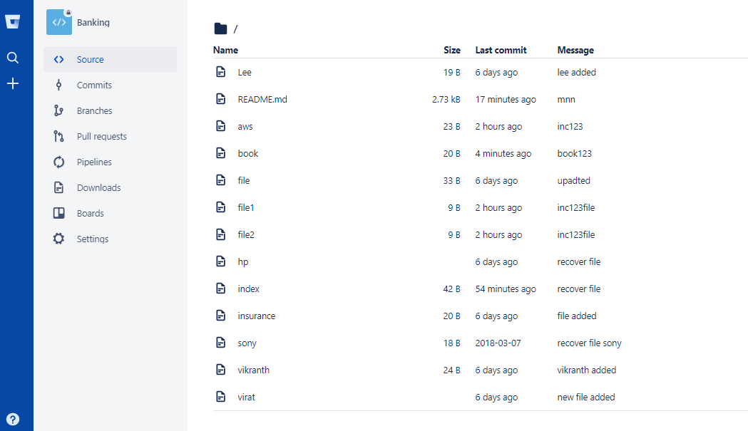

**If ur are getting any fatal-🡪 run as command**

**git pull –force**

**after that add and commit and push to bitbucket**

**If ur are getting any fatal-🡪 run as command**

**git pull origin master --allow-unrelated-histories**

**git pull bitbucket master --allow-unrelated-histories**

* **How can you view the list of branches in git**

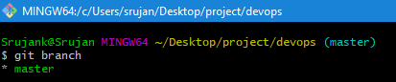

**\*master indicates the present branch name**

* **How to Create or add Branch**

**git branch <give the name of the branch>**

**git branch slave**

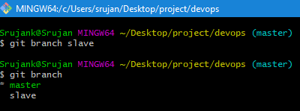

* **How to switch into the other branch**

**git checkout <branch name>**

**git checkout slave**

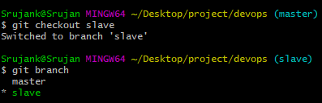

* **How to switch into the master**

**git checkout master**

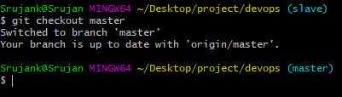

* **Adding and committing and pushing files to slave branch**

**cat > codedoc**

**git add -A;git commit -m "codedoc123";git push origin slave**

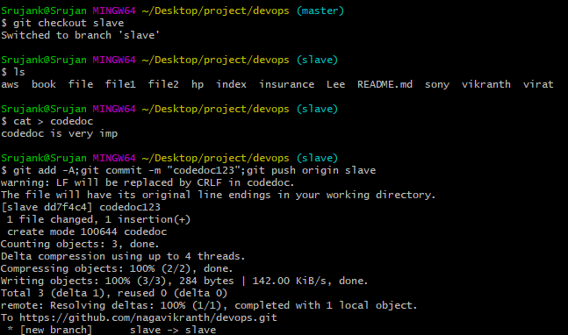



**Check in github**

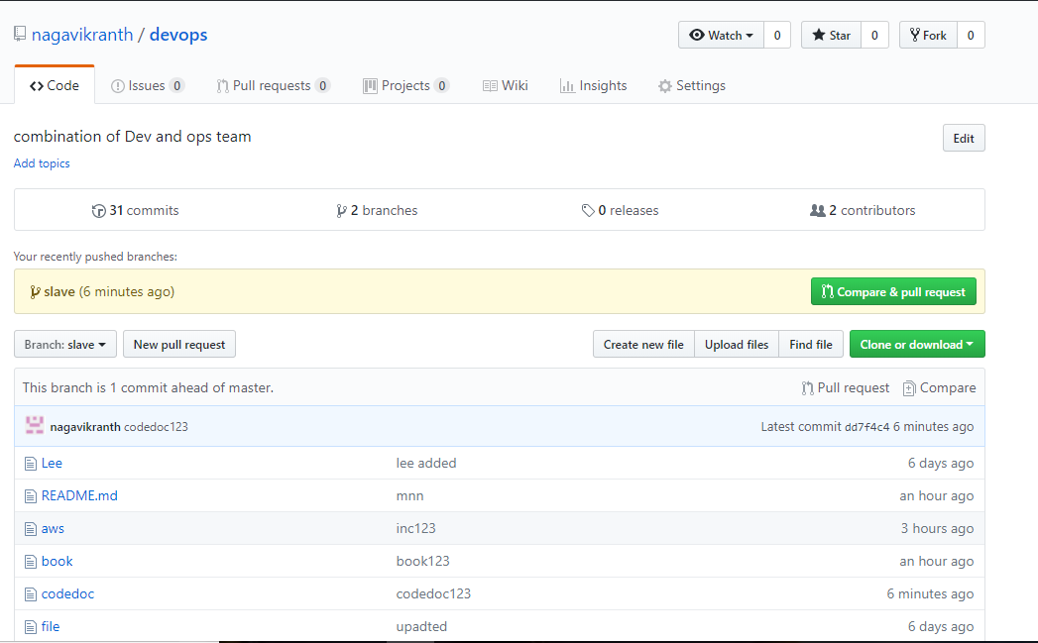

* **How do you merge a different branch into your active branch**

**Checkout from the current branch -🡪 merge the branch**

**git checkout master**

**git merge <branch name>**

**git merge slave**

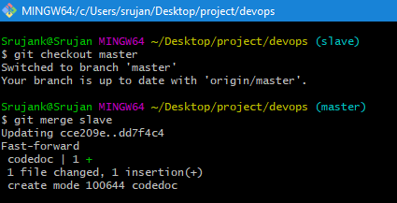

* **How to delete branch**

**git checkout –d <branch name>**

**git checkout –d slave**

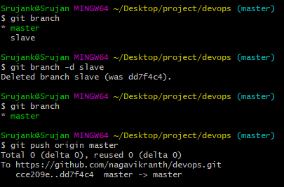

* **How to add ssh key into the git repo**

**Generate the ssh key and copy the public key and paste into deploy key in the git repo ie.---> git rpo settings-->**

**left navigation click on Deploy keys----> Add deploy key ---> give the title name ---> in the key paste the public key and click on Allow write access and add key**

**after that you should active the deploy key for that run the command on git bash ----> ssh -T git@github.com**

**now the deploy key is activated (colour changed to green)**

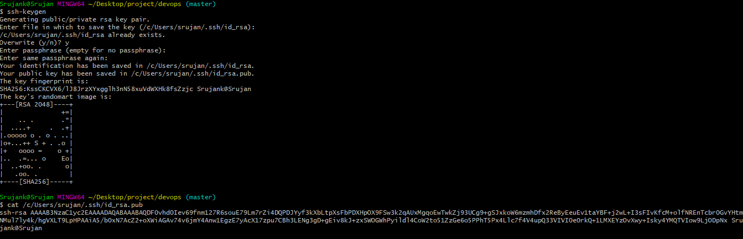

**Copy the public key**

**Now go to git hub repo settings-🡪 left navigation Deploy Keys---🡪 Add Deploy key**

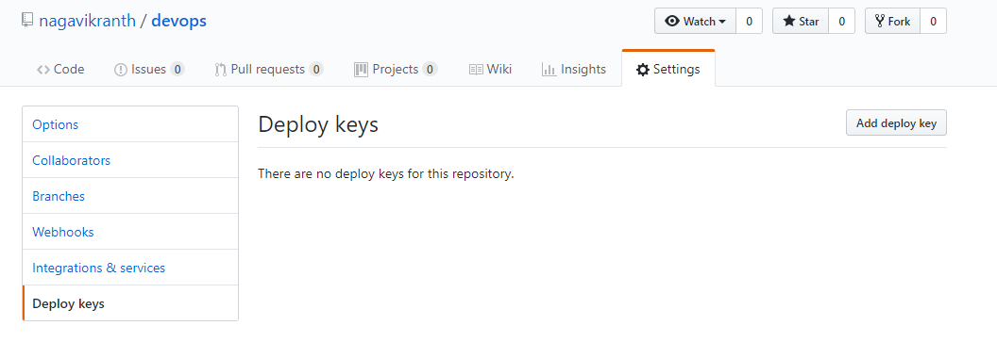

**Add deploy key-🡪 give Title name -🡪 in the key session paste the public key and click on allow write access-🡪add key**

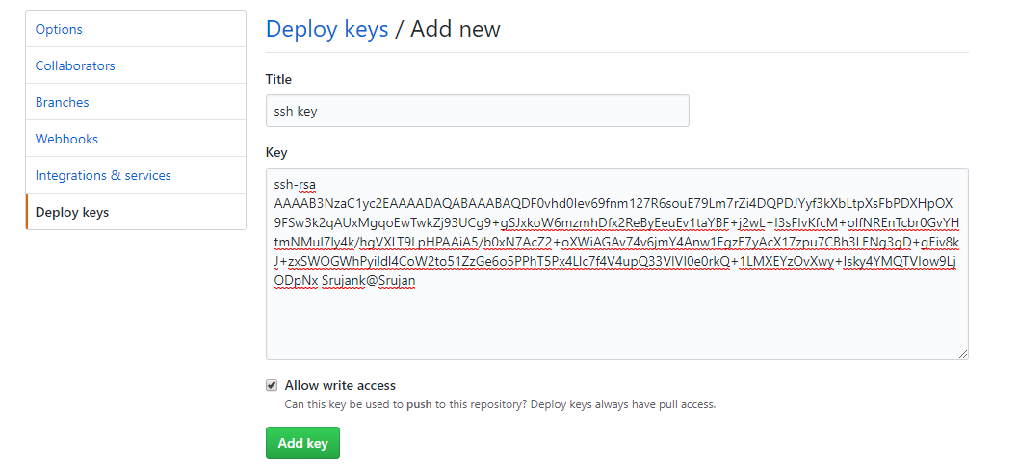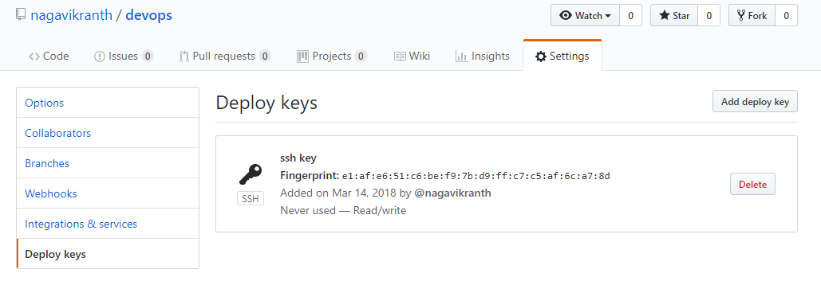**it is just added in Deploy key-🡪 u have to active it (color in black)**

**Rum command to active the deploy key**

**ssh –T** [**git@github.com**](mailto:git@github.com)



**Now checkout in github deploy keys**

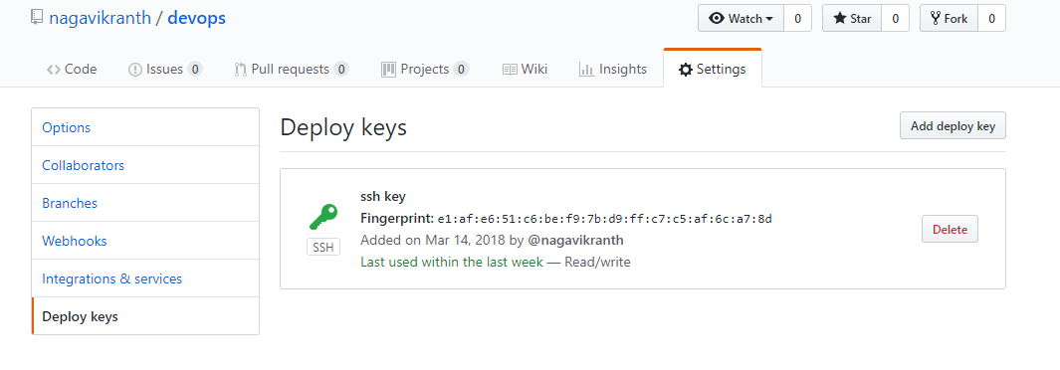

**Now it is activated (color changes to green)**